[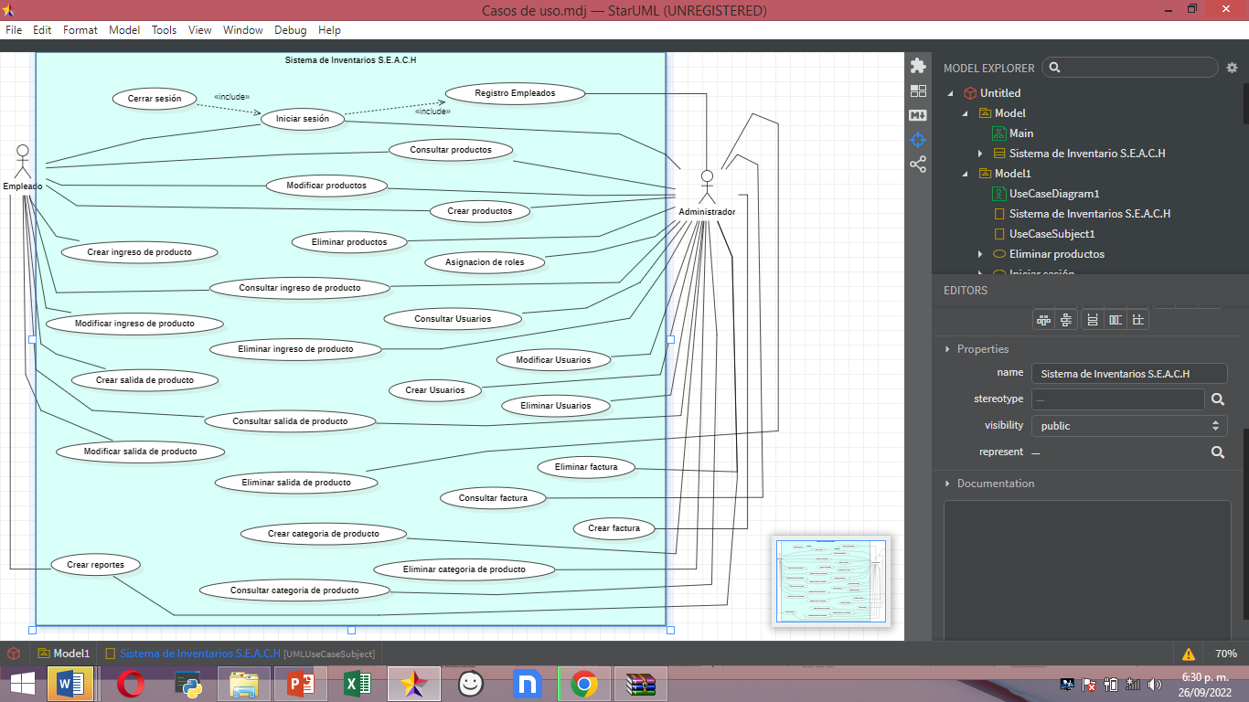](https://docs.google.com/document/d/17UYdjLQfW7JGoo_EtzatcNbJYluRk65e/edit?usp=sharing&ouid=106404031230836045745&rtpof=true&sd=true)